**Jenkins Master-Slave Assignment** 29/06/23

Establish a Connection between Jenkins Master and Slave servers.

Step 1: Create a Jenkins Master and Slave server in AWS Console

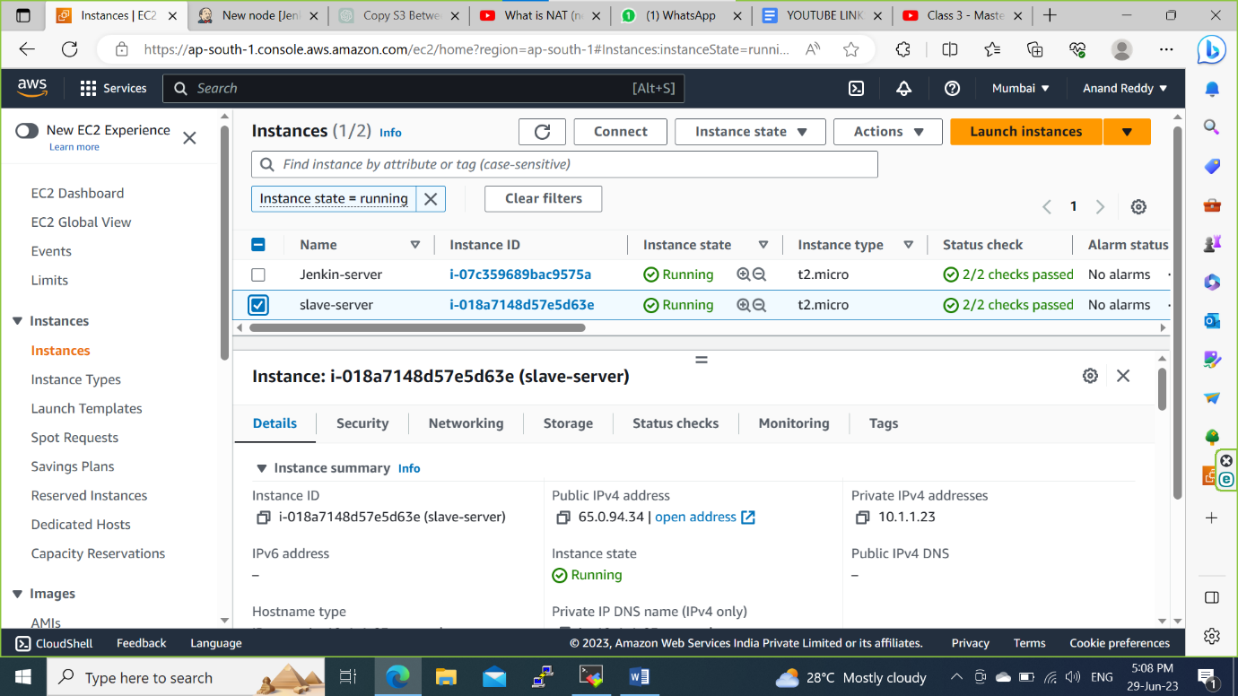

Step 2: In Jenkins Webpage click on Manage Jenkins and select Nodes and clouds

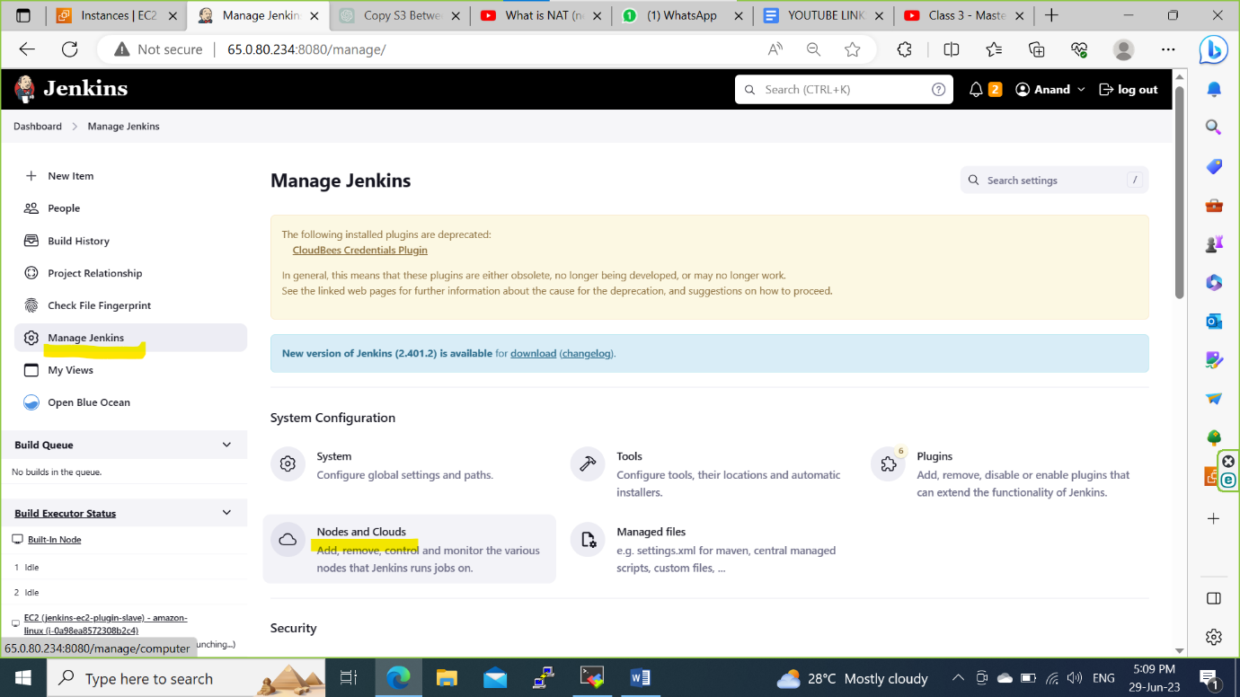

Step 3: Click on New node and give Node name and click on permanent Agent and click on create.

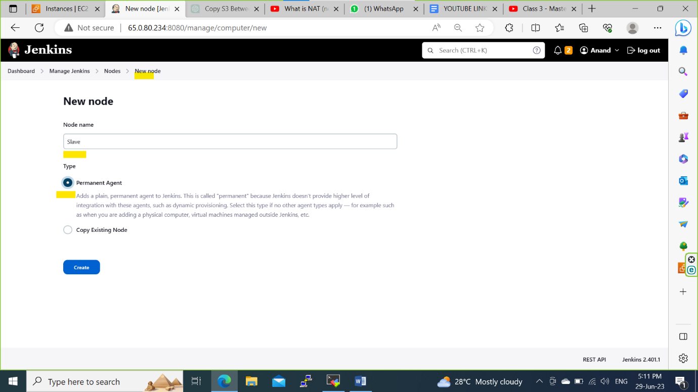

Step 4: Enter the node details and add credentials by clicking on manage Jenkins and Credentials

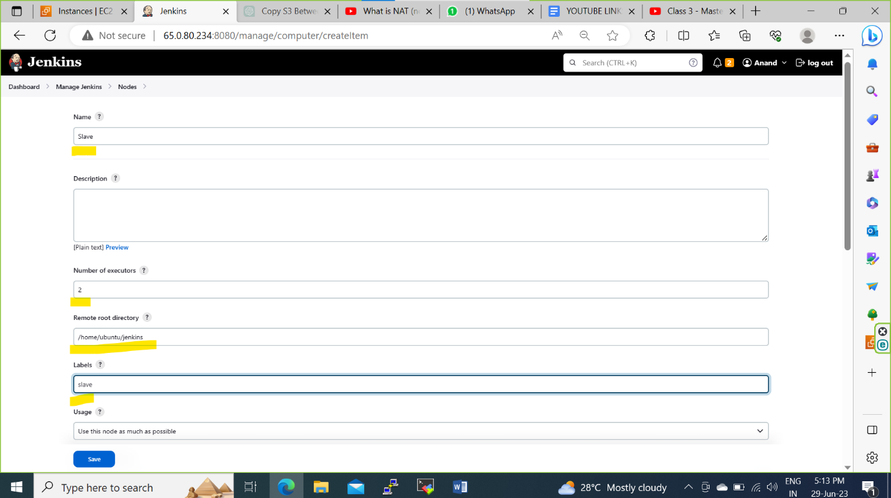

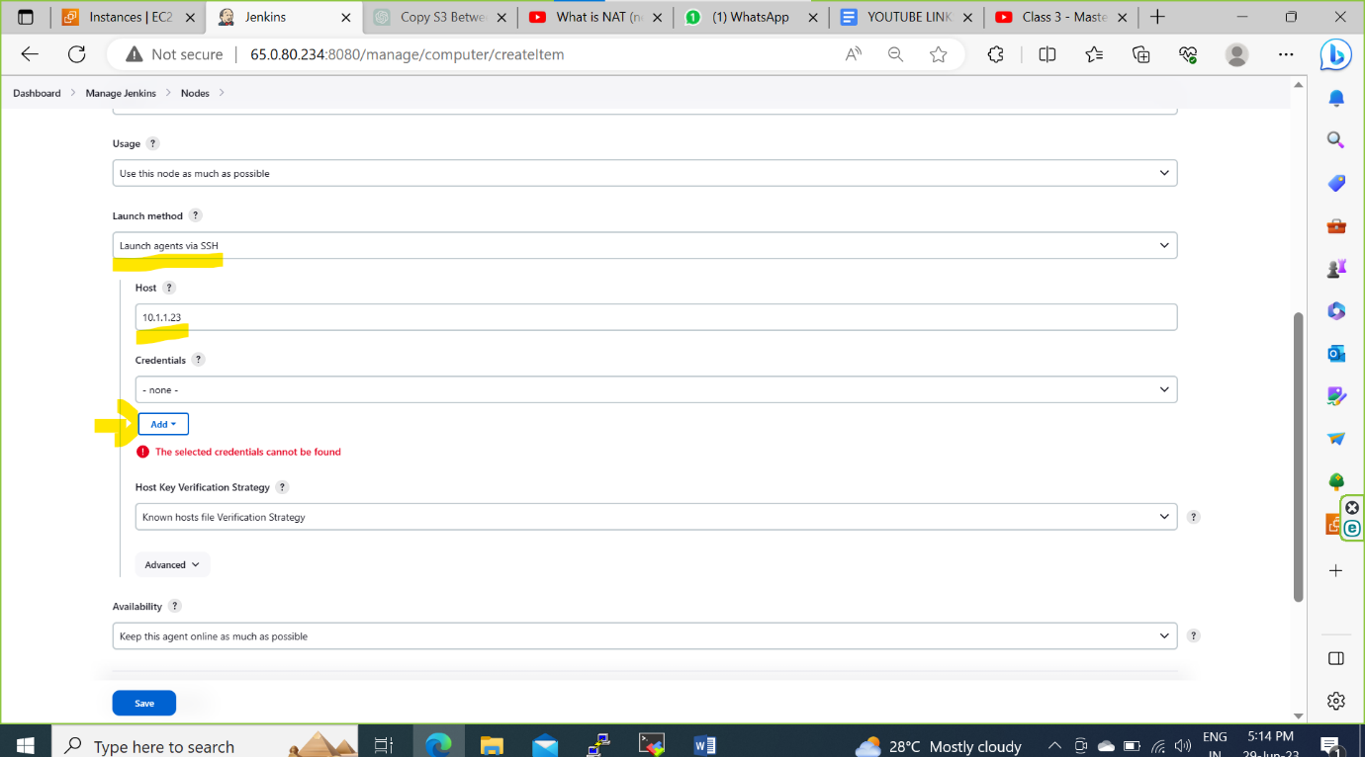

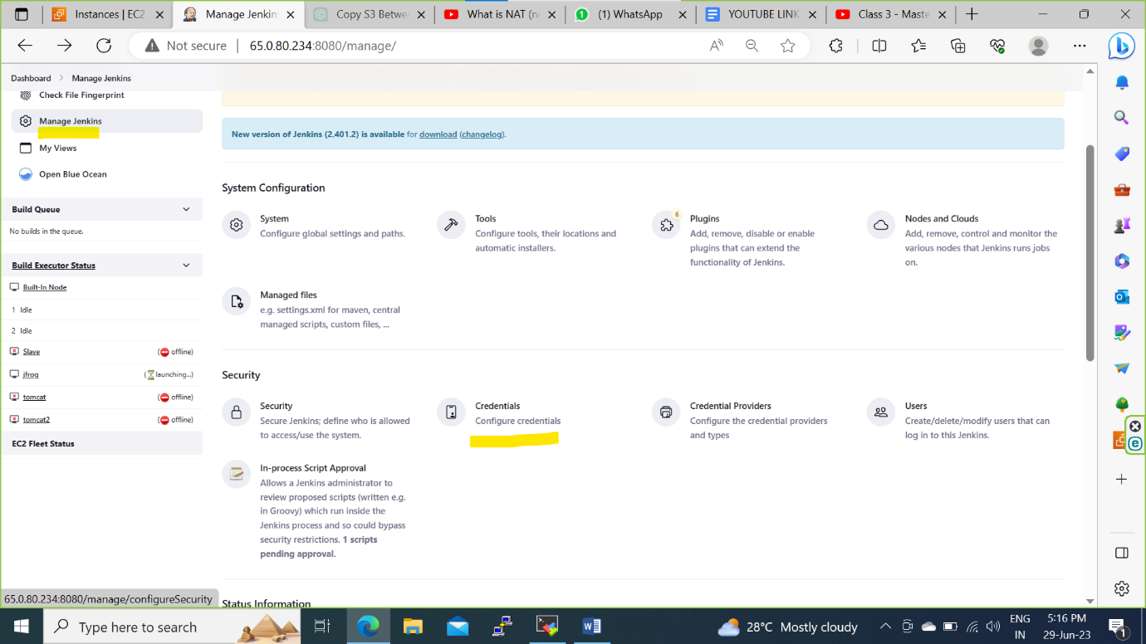

Step 5: Click on global in domain section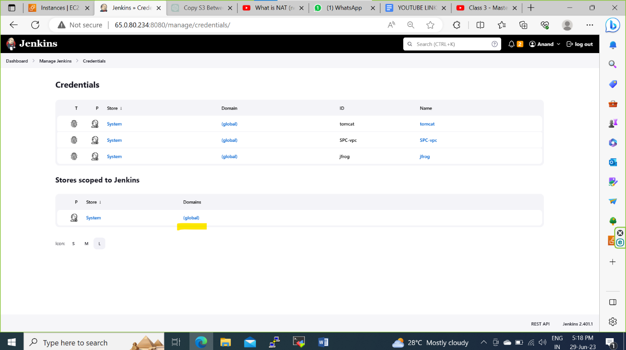

Step 6: add the credentials details and add the private key of slave server(using .pem file)

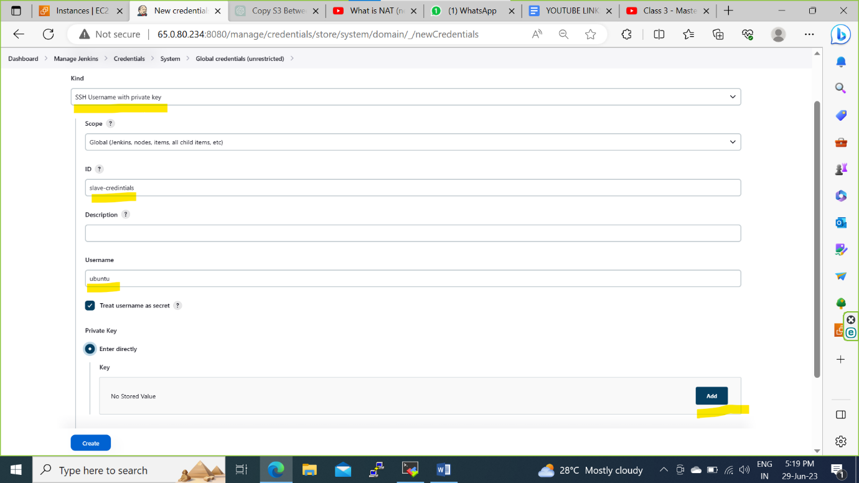

Step 7: select the added credentials and click on save.

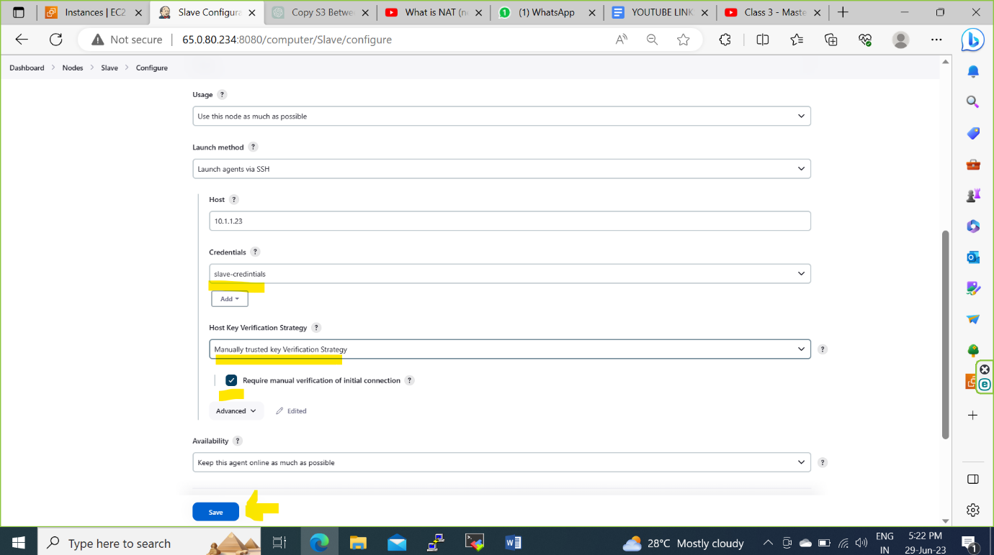

Step 8: Click on Trush SSH host ket and click on yes.

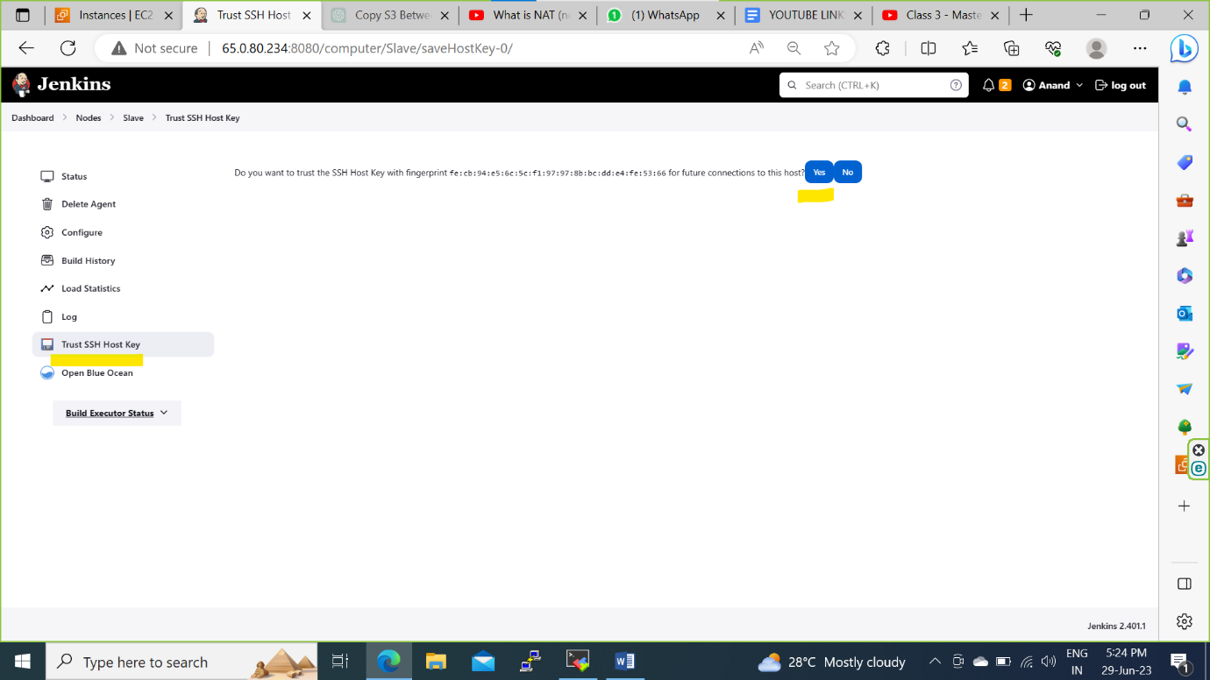

Connection Successfully established

